MINUTES
PPEHOA July Meeting - Monday, 07/16/2018

Attendees (circle attendees): Paul Erickson
Hank Wilcox
Doug Corley
Jon Martin

Call to Order: 7:05 PM

Financial Report:
Checking Account as of 06-28-18 $ 5,513.36
Savings Account as of 06-30-18 $17,020.62

Old Business:

- CHIPPING + BBQ
  - CUSP charges of $935 at $85/hr = 11 hours. To pay, with $50 extra to each of 2 CUSP workers.
  - Residential owners billed? Invoices for non-dues paying residents going out in July.
  - $35 Cash to deposit Paul has $35 from Sterling Point’s Patrick Mazzoni, 1883 Tenderfoot
  - BBQ Attendance Try photos next year (for our web site, mailings, & annual meeting presentation)
  - Gift to Steve Christensen Completed $207.40 reimbursement check to Tracy
  - Confirm Fall Schedule October 12-13. (CUSP = Coalition for the Upper South Platte, http://cusp.ws/ )
  - Chuck Hutton Was suggested to assist Hank (& Jon) on chipping project.

- OFFICER CHANGES Hank’s records to Paul
Resolution - substituting Paul to bank account
Web site - Tracy please update “Board Members”
- please add email address to Home page / elsewhere
- please add P.O. address to Home page / elsewhere
-please change email solicitation + post more prominently
OLD: If you want to receive HOA materials via email instead of US Postal Mail, it will save us money. Send a message to ppehoa@yahoo.com, and let us know you're willing to accept email instead of USPS mail.
NEW: Please submit your email address(es) to ppehoa@yahoo.com to improve HOA communications for efficiency and emergency purposes. We need to modernize + to save mailing costs. Thank you!
- Members list (Paul can distribute read-only copy)
Secretary: Discussed appointing outsider, do rotations, or other.

- DUES PAID 43 paid (26% of 164 lots).
Please add web site dues paying capability.

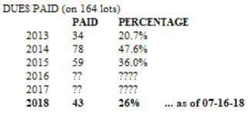

New Business:

- Inquiry by Land Title Guarantee (by “Tiffany”) for our HOA minutes + financials re S. Christensen’s property.
(Doug replied to her saying, see all minutes on our web site & let us know.)

- Science project student, Peyton Wertz at Kingston Schools, suggested we add a wildfire website: https://www.homeadvisor.com/r/wildfire-facts-and-safety/

Authorized DRAFT REPLY: Dear Peyton & Bridget, We are glad that you found helpful wildfire information at our HOA website. Thank you for letting us know about your work and for also suggesting the Home Advisor's page on wildfires: https://www.homeadvisor.com/r/wildfire-facts-and-safety/. We don't want many things on our website &won’t add this link , but we truly admire your work to help people protect themselves and their property from fires. Good for you & keep up the good work! Sincerely, PPEHOA
FROM OUR WEB SITE - "DOCUMENTS" SECTION:
Douglas County Wildfire Mitigation Standards 44 pages (defensible zones: 1,2,3 = 15' - 70' - remainder)
Greater Sage Port CWPP (Community Wildfire Protection Plan) 50-page report + 50 pages of attachments (includes ppehoaMAP at page 60).

- DEBRIS PILE at 8175 Silverheels Pl, Kurt + Sandra DeSHAZER (bought 1997). 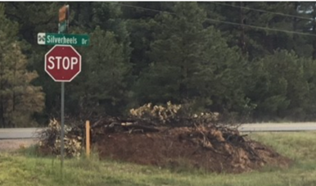 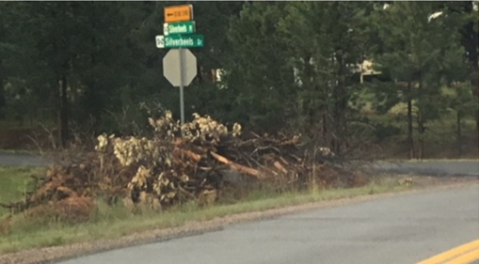

Paul to draft letter to 1439 Silverheels concerning pile.

- HOA Records File cabinet at Doug’s to review. Postponed until fall or winter.

- Regulations Discussed possible concerns re sidewalk sales, drones, ATVs, chickens, home rentals,
& Castle Rock’s sex club problems.

- Fire Dept’s Budget Crisis Negative budget impacts from Gallagher + Tabor constitutional amendments.
        - See video: “Larkspur Fire Protection District – Hard Times Ahead”
http://townoflarkspur.org/we-need-your-opinion/
- Possible broadcast email to PPEHOA members? (attach “Active Voter Letter” only)
- Need to support stable funding for fire department

ACC: No new business

Meeting adjourned: 8:30 PM

